101027496

COMP3064 – Assignment 1 – 2D Shooter

Yuming Wu

Gold Hunting

2017

Contents

Detailed Game Description 2

Controls description 2

Interface Sketch 2

Screen Descriptions 2

Enemies 2

Scoring 2

Sound Index 2

Art / Multimedia Index 2

# Detailed Game Description

* + - Gold hunting is the 2D shooting game.
    - Player controls a diver to avoid ghost that can kill the player.
    - Player hunts gold coins at the castle which sank on the bottom of an ocean.
    - Player need to collect enough coins to gain enough points to win the game – 100 points per coin, to win – 9999 points
    - Player lose lives if he/she caught by a ghost – one life per hit.
    - Player gain lives if he/she collect the bullet box, one life per one box – one life per box.
    - Diver can shoot the ghosts to get more points – 200 points per ghost.
    - When diver out of life, Game Over.

# Controls description

* + - Player use standard key “WASD” to control the diver position.
    - “space” key to shoot the bullet

Interface Sketch

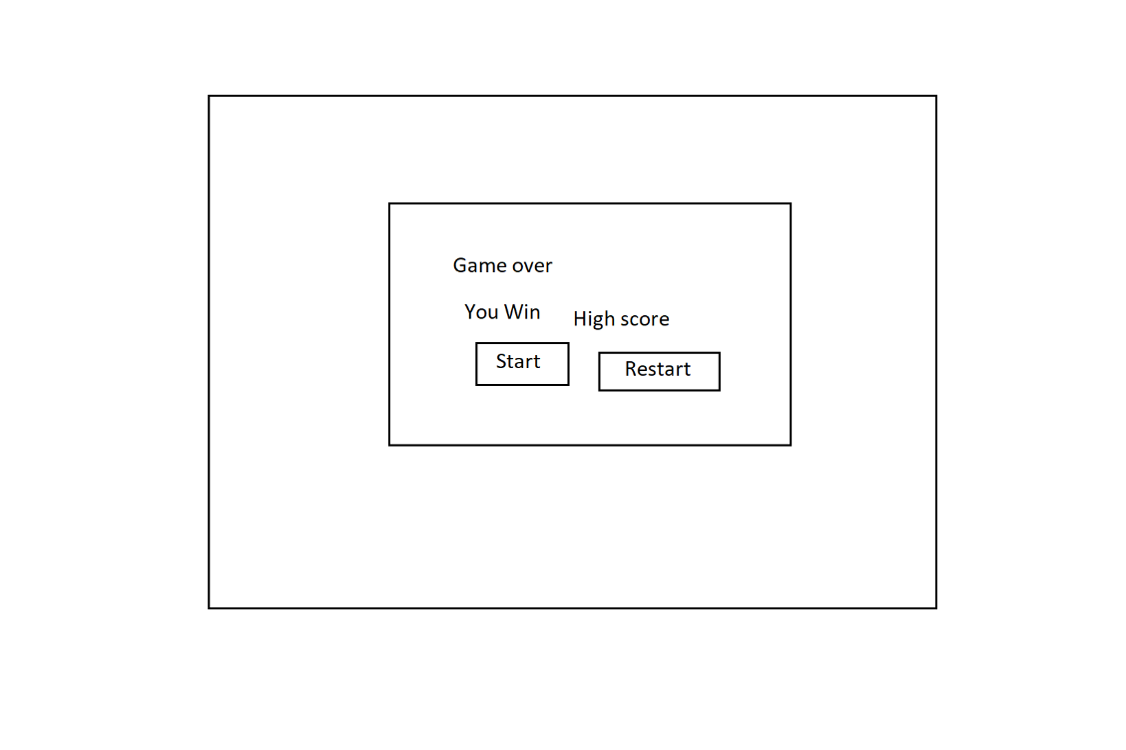

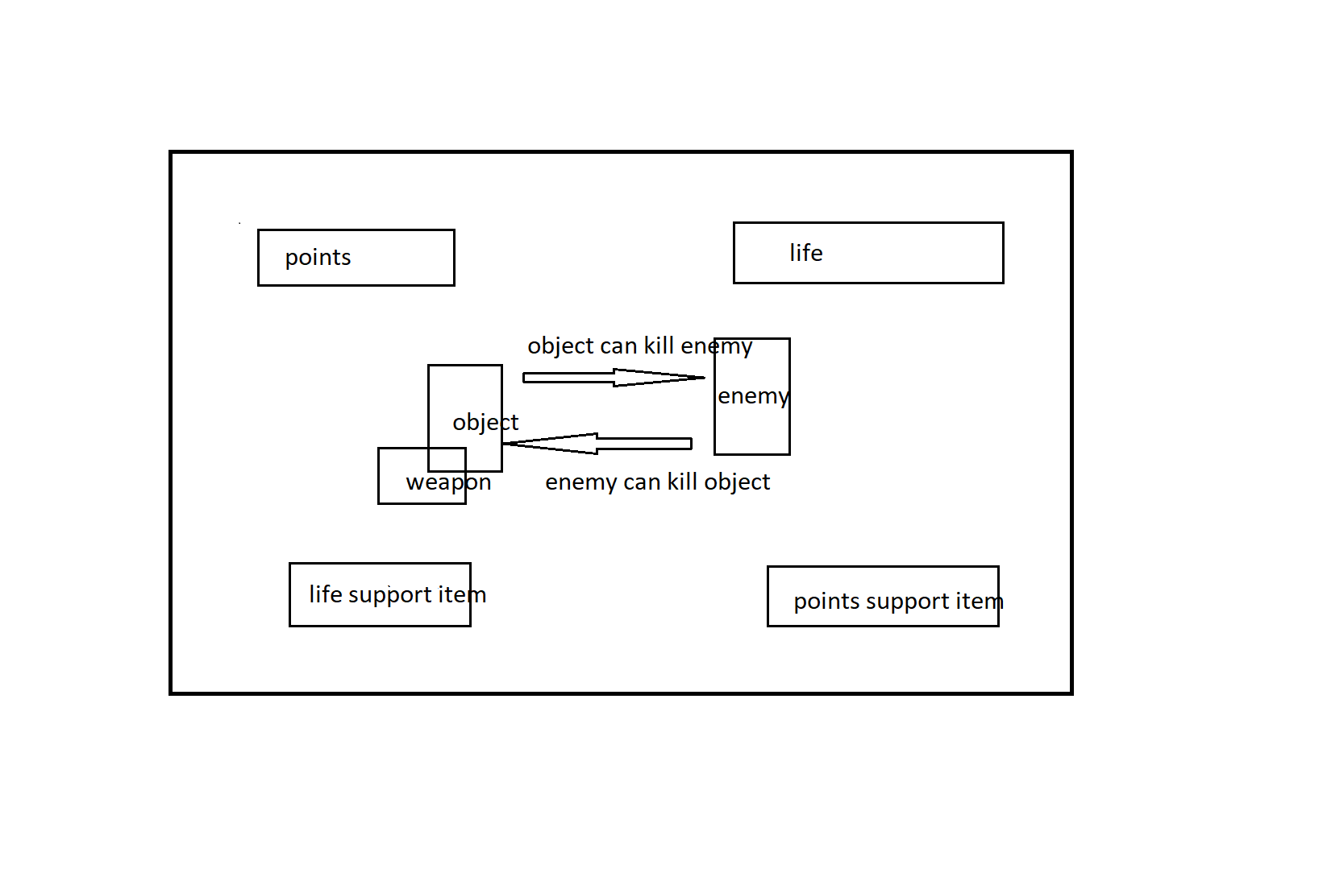

Screen Descriptions

|  |  |
| --- | --- |
| Start State |  |
| Gameplay State |  |
| Game-End State |  |

Enemies

**Ghost:**

* + - Placed outside of the frame.
    - Float into the screen with different speed and position
    - It creates more when they got hit or kill to challenge the player
    - They can be killed by a bullet

Scoring

* + - Collect coins: earn 100 points/ per coin
    - Kill ghosts: earn 200 points/ per ghost

Sound Index

|  |  |
| --- | --- |
| Background audio |  |
| Collision Audio : _ghostAudio |  |
| Collision Audio : _coinAudio |  |
| Collision Audio : _bulletboxAudio |  |

# Art / Multimedia Index

|  |  |
| --- | --- |
| **Blackground – a Castle under the sea’s floor** |  |
| **Diver – a gold hunter** |  |
| **Ghost - enemy** |  |
| **Bullet - Weapon** |  |
| **Bullet box – life supply** |  |
| **Gold coin – point supply** |  |
| **Blood – diver died** |  |
| **Smoke – ghost died** |  |
| **Bubble – background supply** |  |